**NEXMO MESSAGING API :**

* Install the Nexmo Messaging Package into SF from [Github repo](https://github.com/nexmo-community/nexmo-salesforce) with the given instructions.
* Once the installation is done, go to Nexmo Configuration tab in Salesforce and validate your credentials.

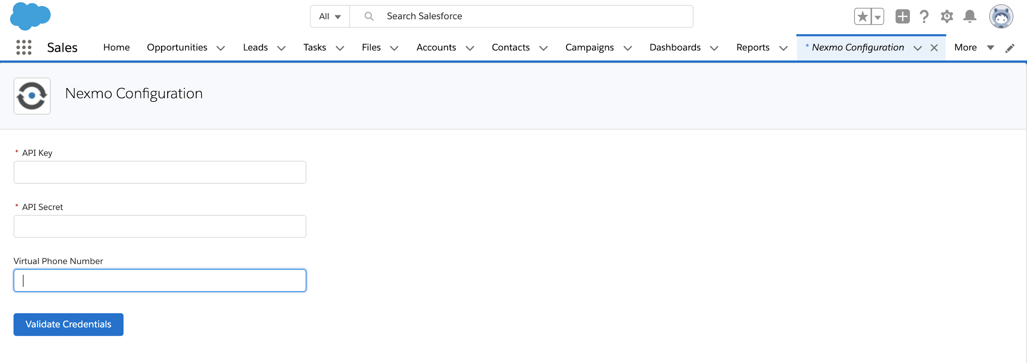

* Make sure the following pre-requisites are enabled before proceeding further :-

1. Enabled Einstein bot in SF org;
2. Enabled chat setting in SF org;
3. Create Chat button in SF org;
4. Create Chat Deployment record in SF org;
5. Create SnapIn in SF org;
6. Community enabled and built in SF org;
7. Deploy Chat button on community to avail bot on Community;

**CAUTION - Make sure the Bot Name in SF org is Send Message(API name Send_Message) because the bot metadata file has the bot with the same name.**

**In case you want to create a bot with different name, ensure that the same name must be updated in the bot metadata file inside the ‘NexmoMessagingBot’ folder before deploying the metadata file in the SF org.**

* Once the pre-requisites have been set up, download the NexmoMessagingBot folder from the **NeuraFlash** Branch of the above [Github repo](https://github.com/nexmo-community/nexmo-salesforce) .
* Zip the downloaded file and deploy the same in the SF org.
* Once done, the bot is ready for use.

**DEMO OF THE BUILT-IN BOT : (All the data displayed is hard-coded and is just for sample purpose)**

* Preview the bot from either inside Einstein Bot section in Setup in SF org or from the community, if the bot is deployed on the community.
* The bot initiates by displaying welcome messages and asking for an input.

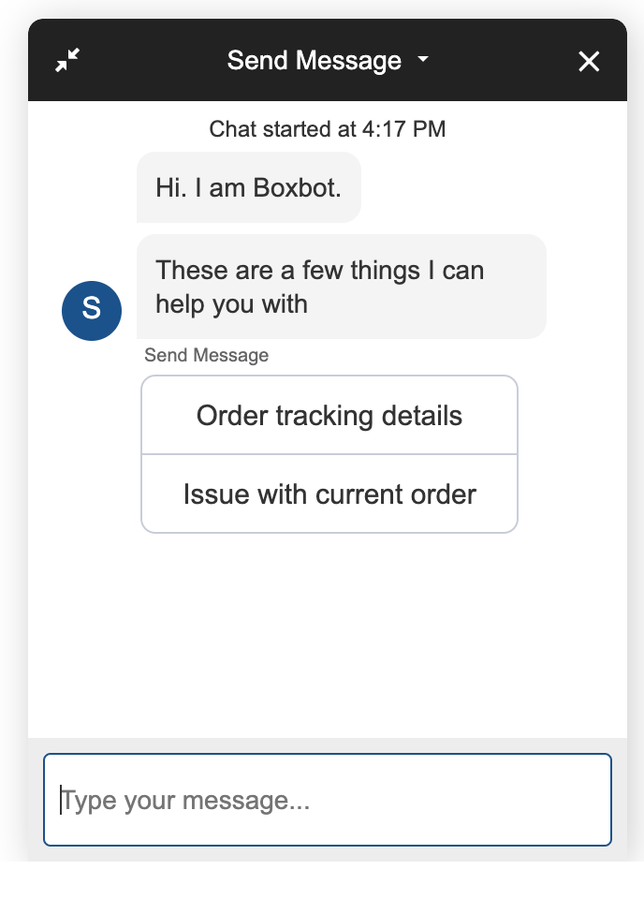

* Choose an option:
* If order tracking details is chosen, the bot shows the details of the order and asks whether the end user wants the details over SMS:

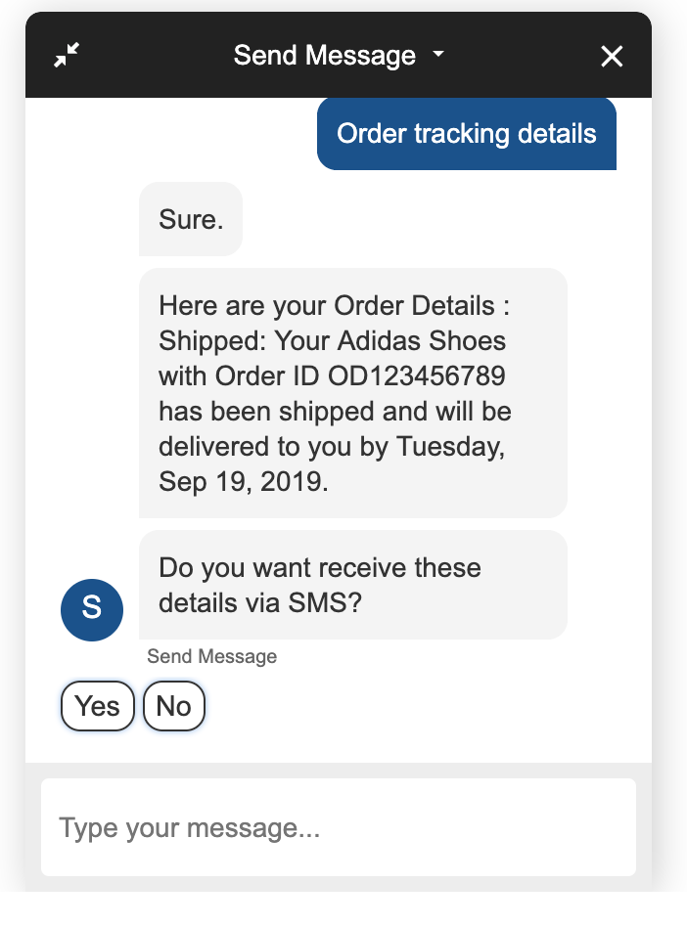

* If No is chosen, the chat terminates with a thank you message.

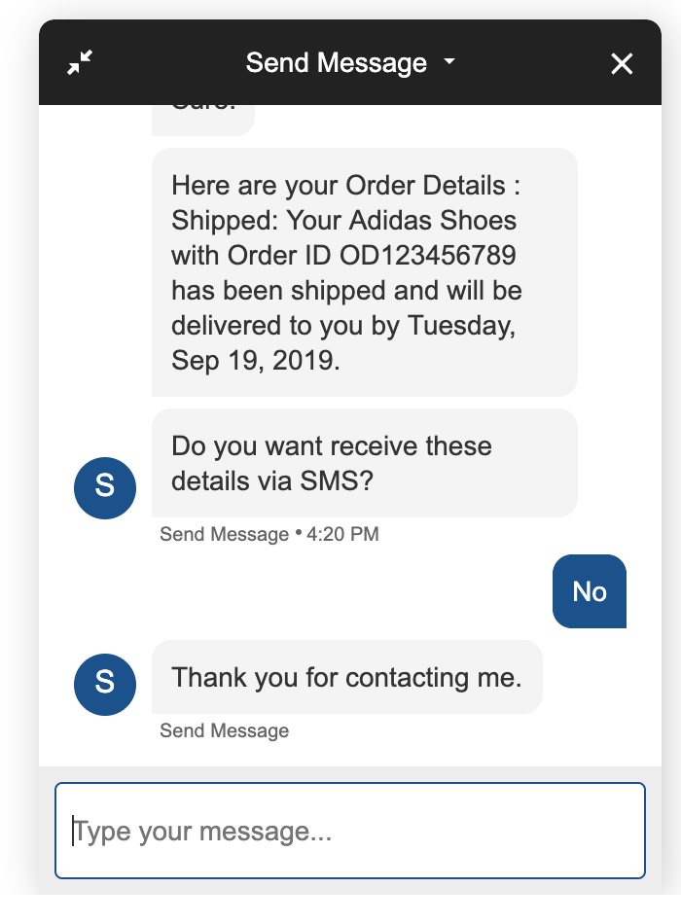

* If Yes is chosen, the bot asks for Phone Number in a specified format to send the order details.

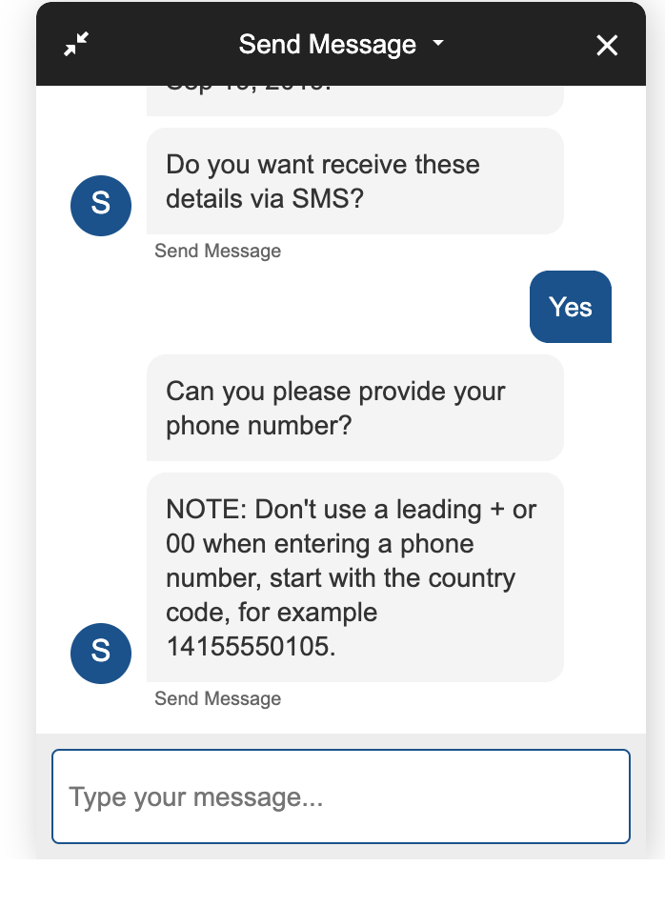

* On the phone number is entered, the bot sends the message and ends the chat with a thank you message.

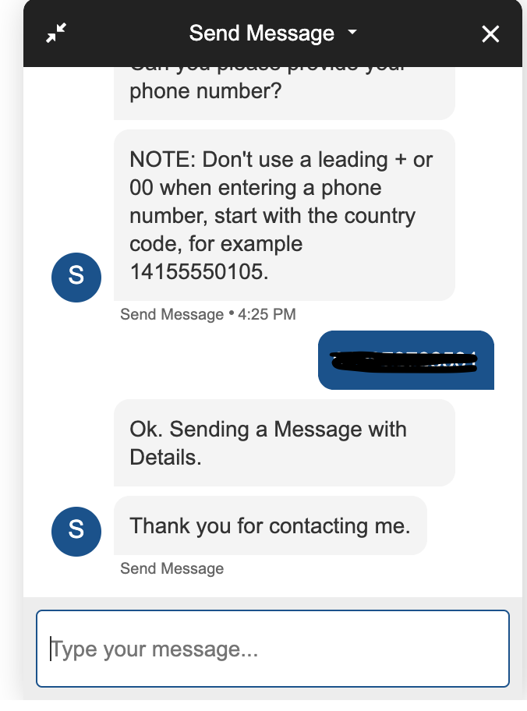

* If Issue with current order is chosen, the bot asks the user to enter the issue details

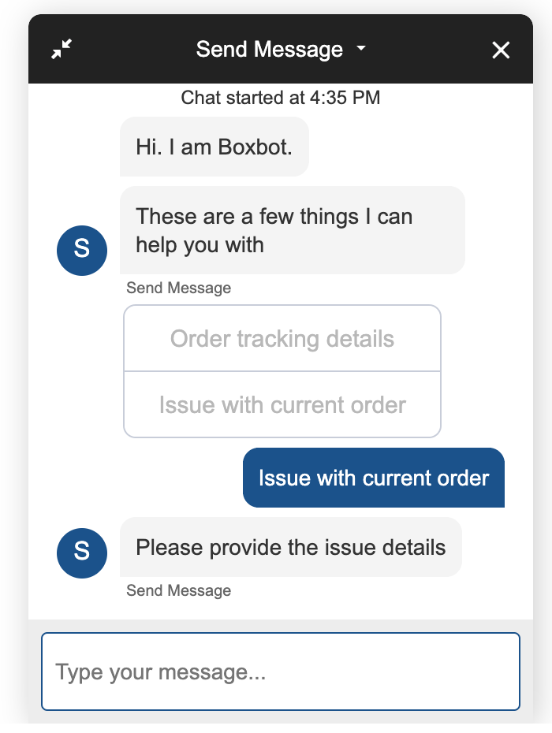

* Once the issue details are entered, the bot asks the end user for phone number to send in the case details that has been logged as per the issue.

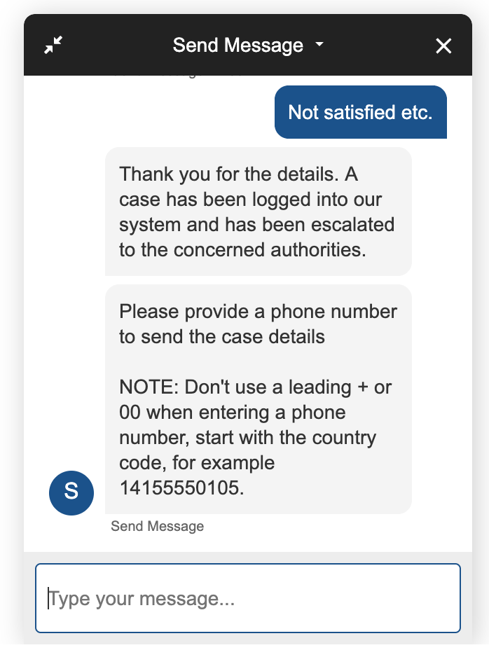

- Enter the phone number in the specified format and the bot sends a message to

the number and ends the chat with a thank you message.

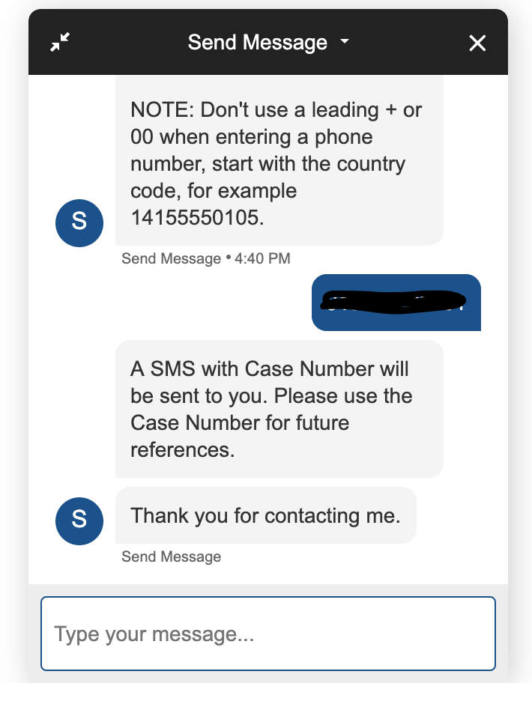

* Attached is the screenshot of the messages received

